Cloud kicks wants to use salesforce for these tasks.
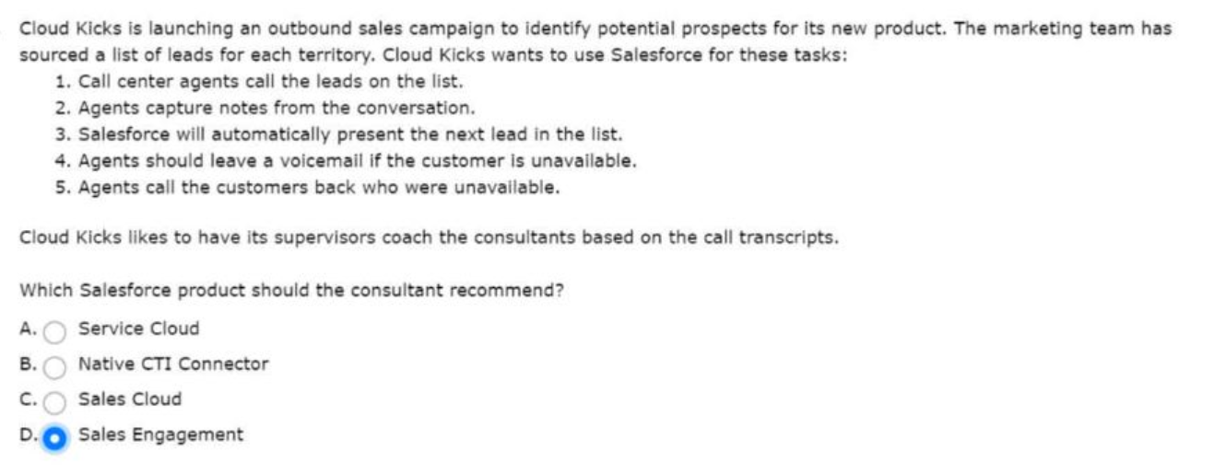
And then move them to production for release.
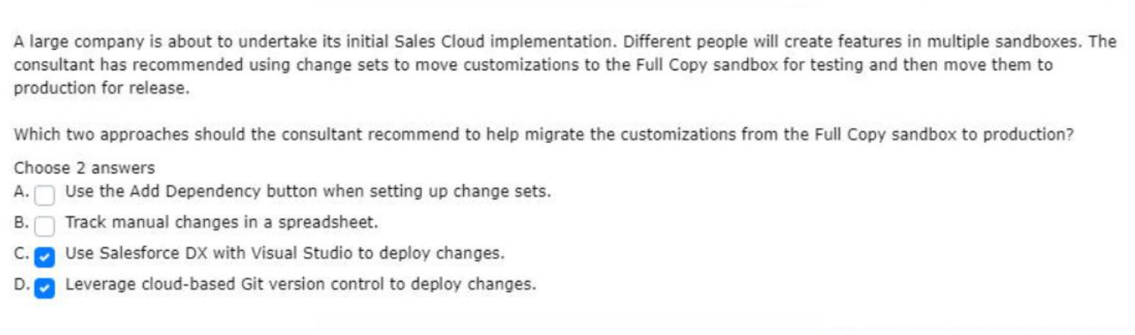
Successfully deployed sales cloud at cloud kicks

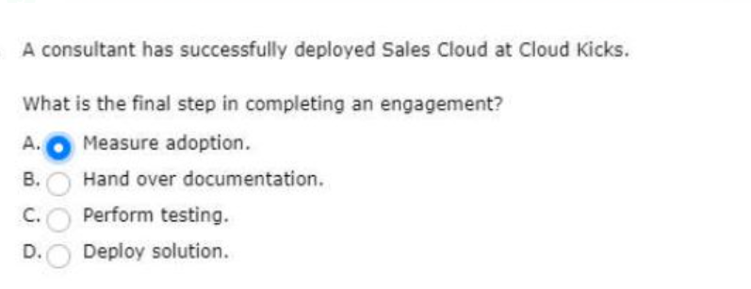

The product-specific sales cycle for the business unit.
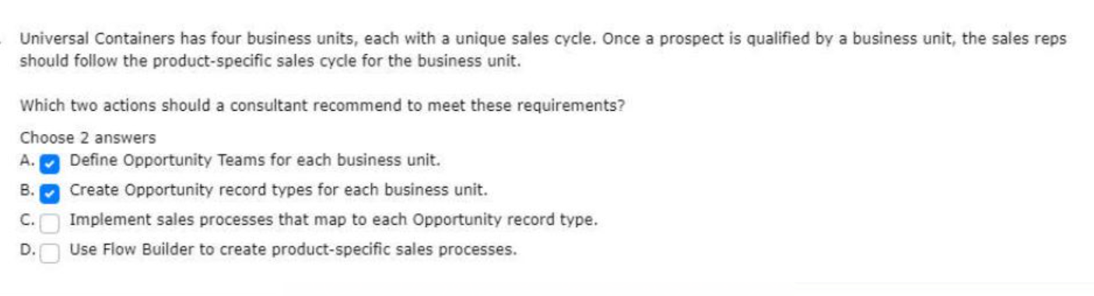
Wants to dive deeper into CK’s process and pain points.
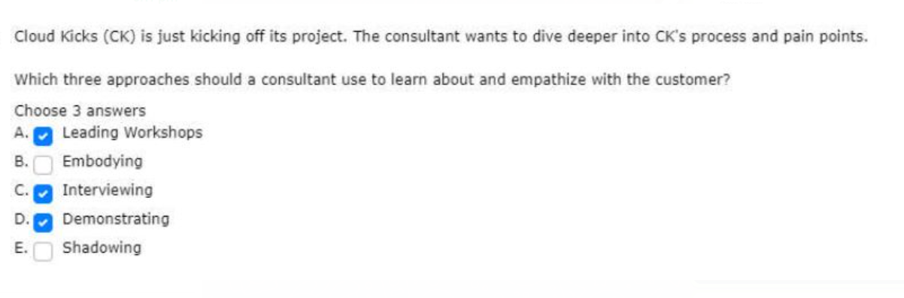
On the location of the related account.

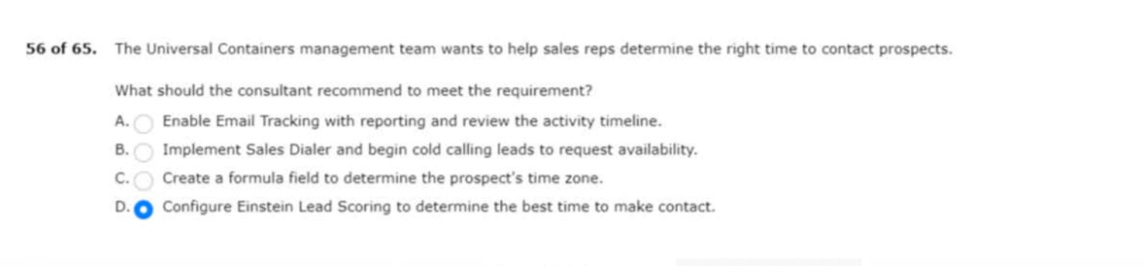
Opportunity list in collaborative forecasting.
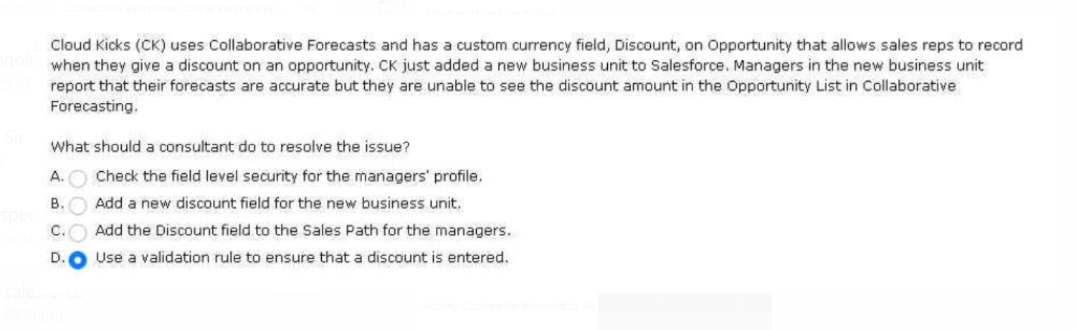

On sales pipeline changes on a monthly basis.
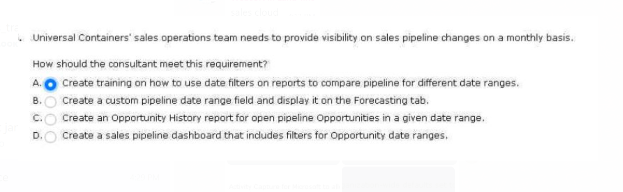
With microsoft contacts and vice versa.
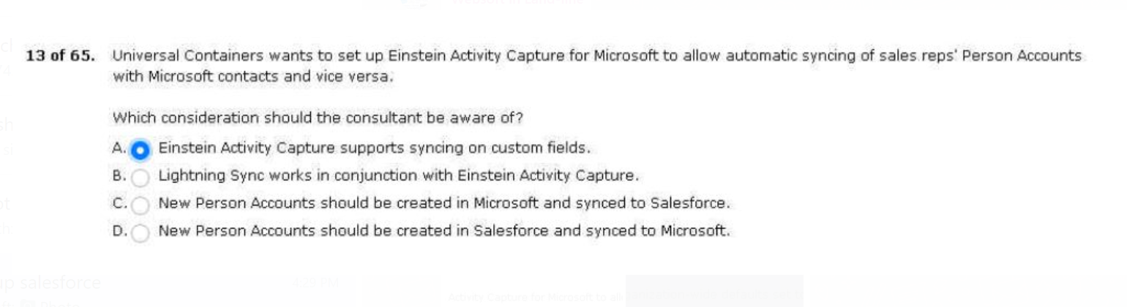
Defaults set to private for account.
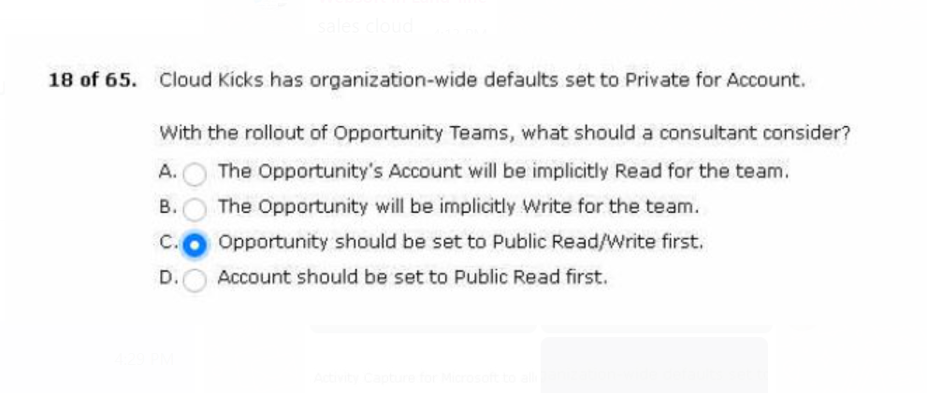
That are tied to accounts they own.
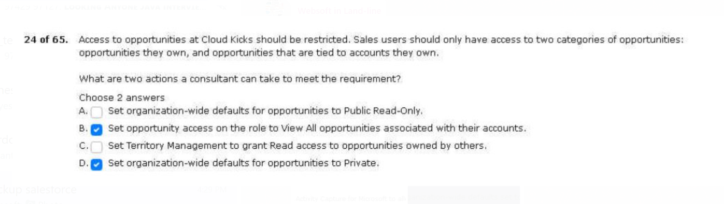

The admin has already set up a matching rule for leads.
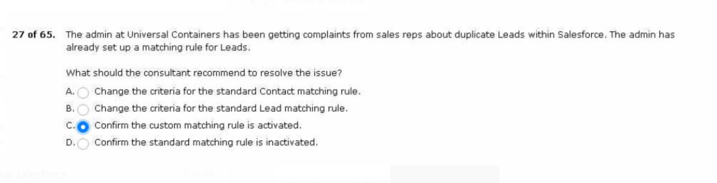
For the account on the opportunity record.
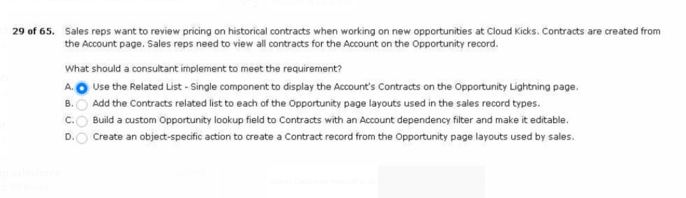
Office and when they are without an internet connection.
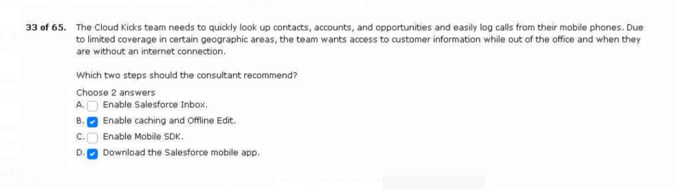
And wants to keep account data current.
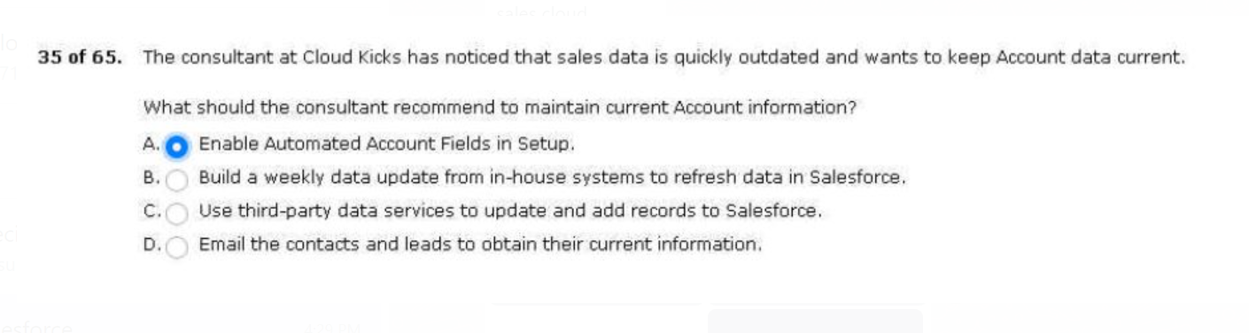

Process within the overall business as a whole.
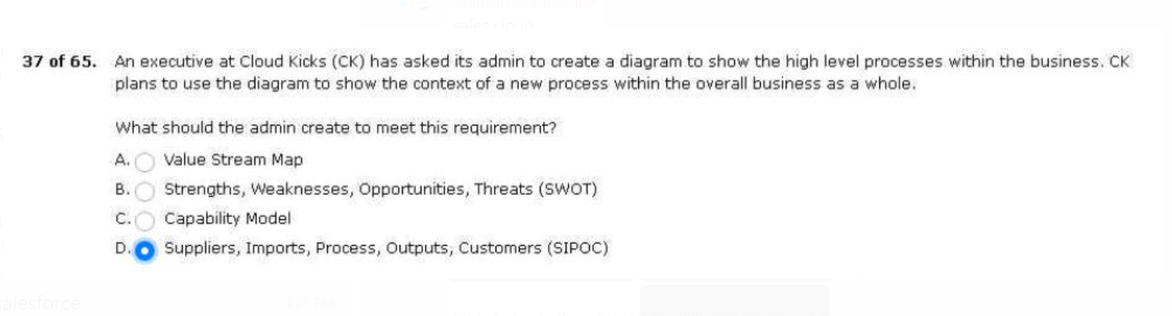
Are getting less attention than deals that are won.
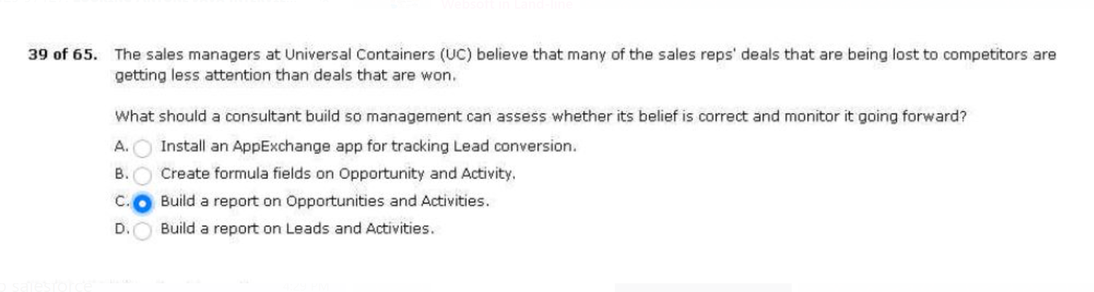
A custom formula field on the opportunity.
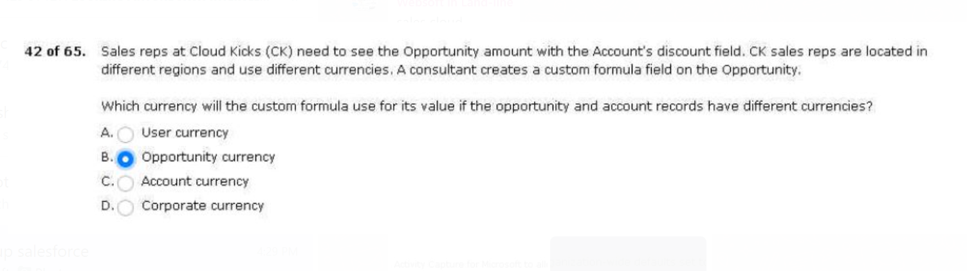
Sales reps have yet to enter the data.
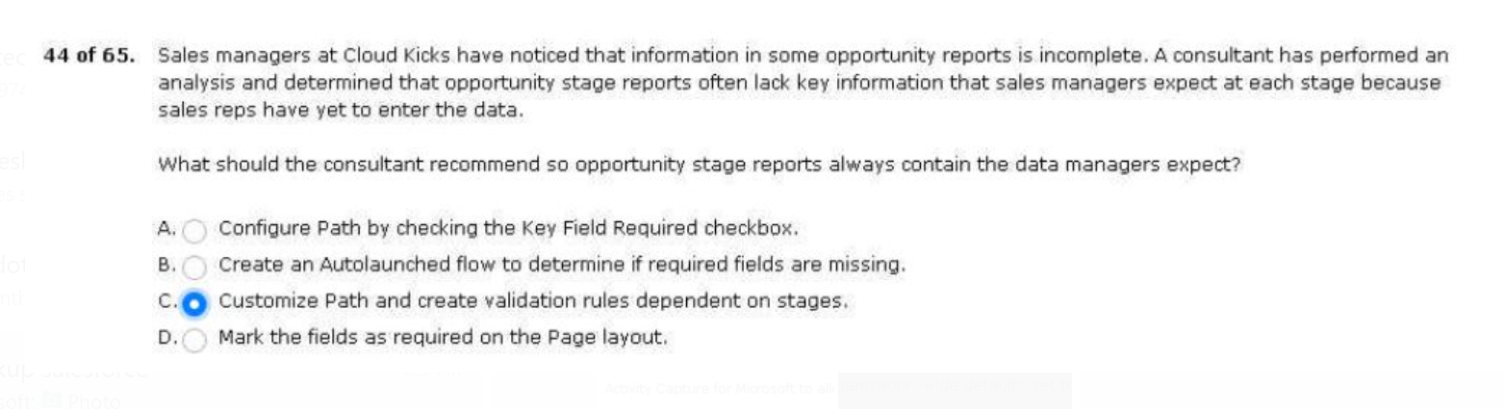

On any opportunities created as a result of a campaign.
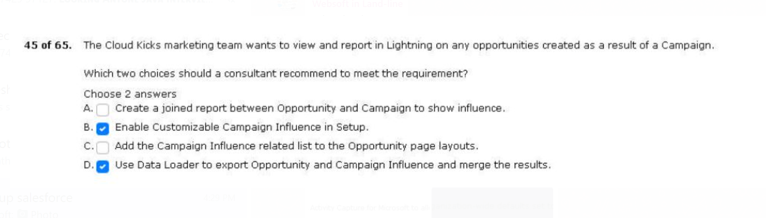
Hired a consultant to complete the project.
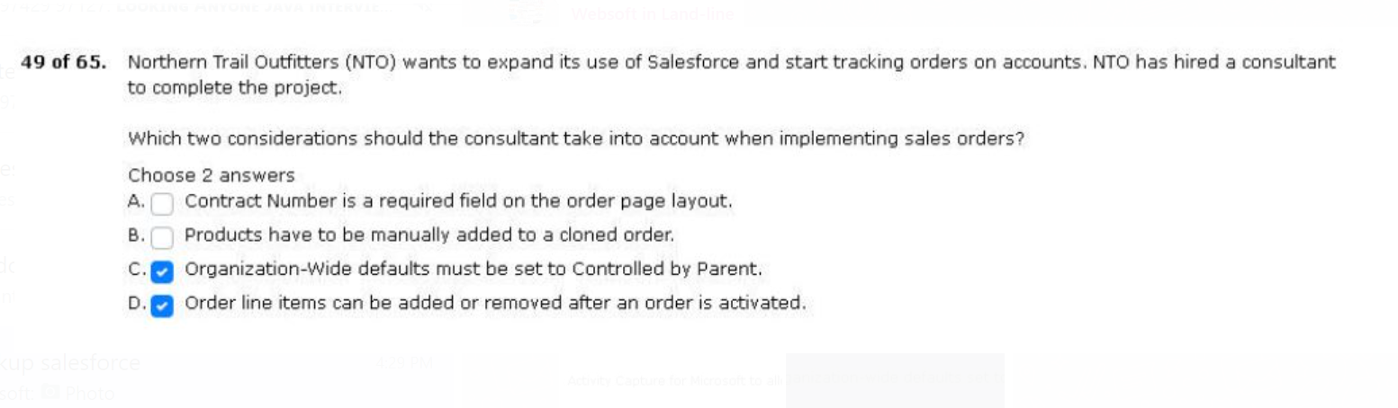
To implement einstein activity capture (eca).
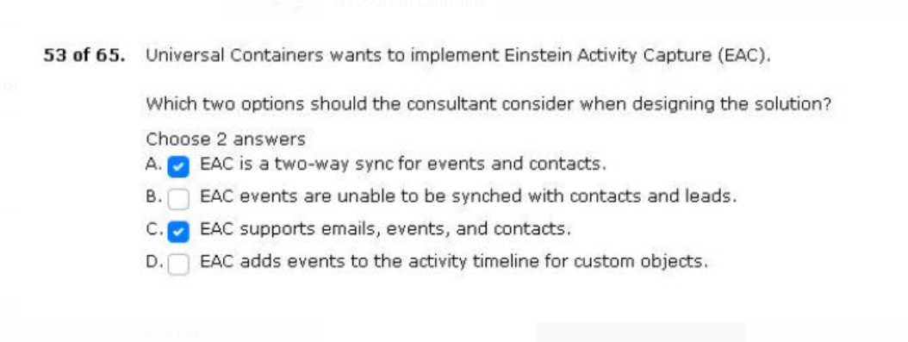
Impacts the number of won sales deals.
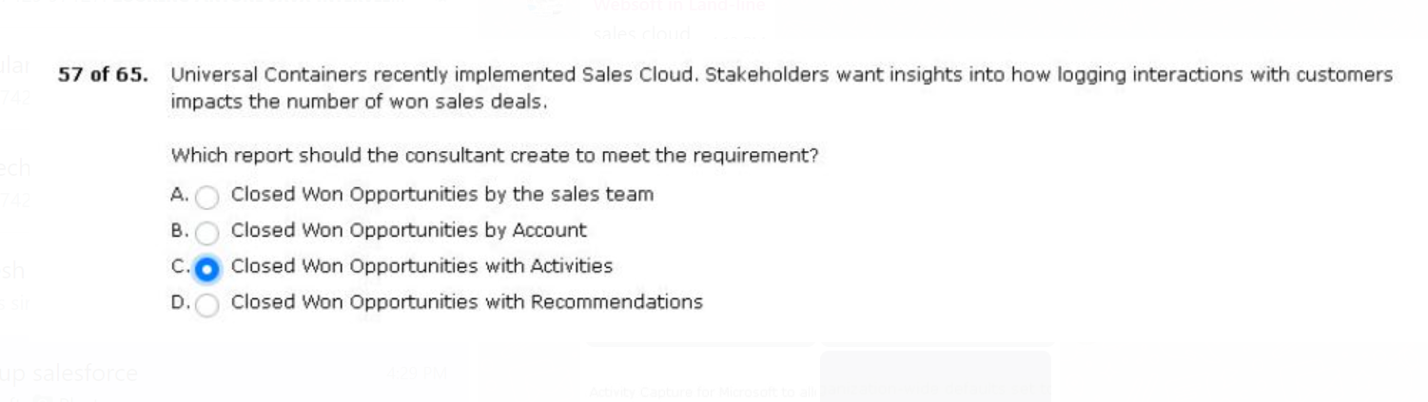

User adoption and data quality in salesforce.
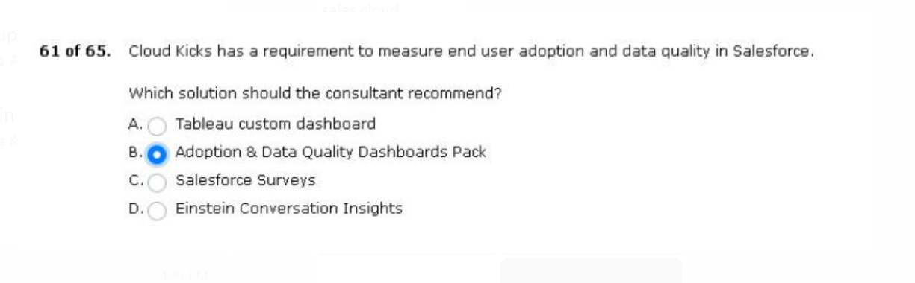
Few sales stages overlap between the three product lines.
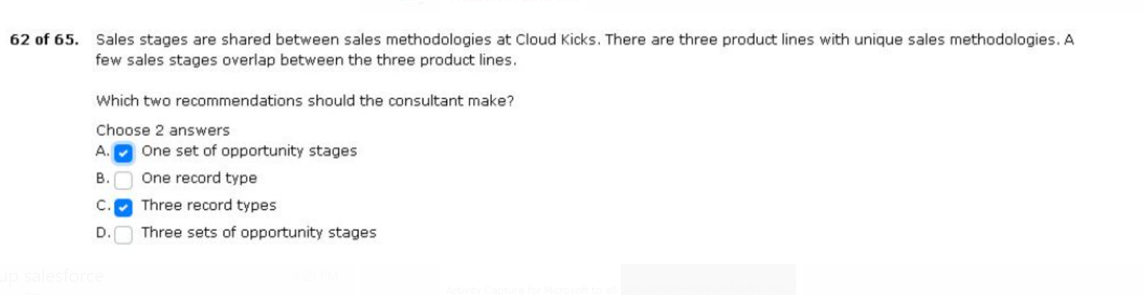
Process maps nto will use as its guide.
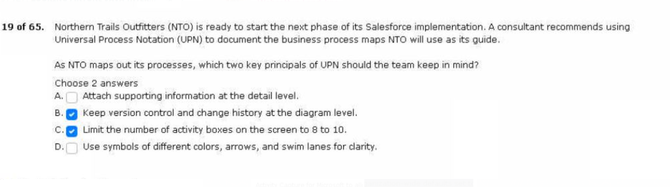
Marketing initiative to report on success
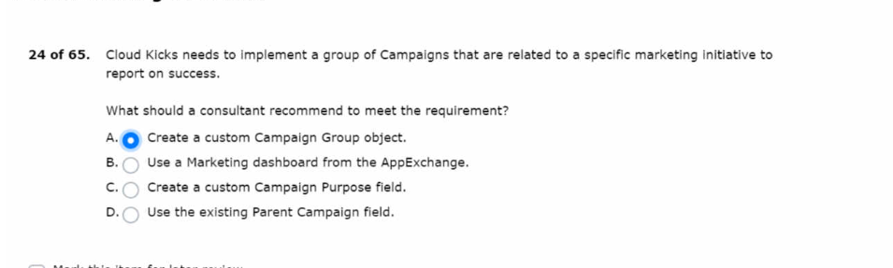

Reports be shared with the sales team,
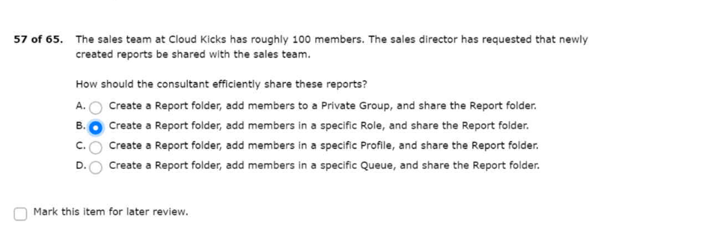
1.requesting a detailed roll-up forecast for territories
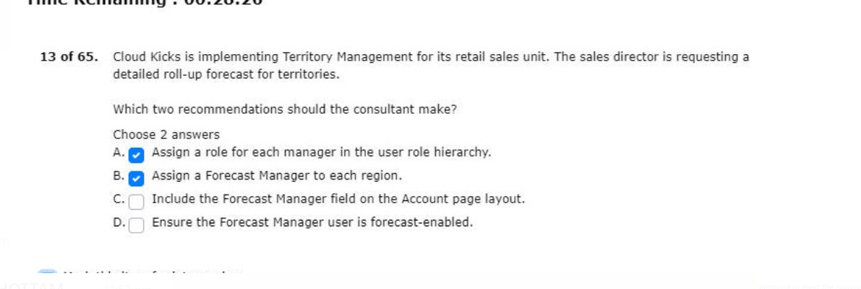

2.been pursuing contain outdated and missing information.
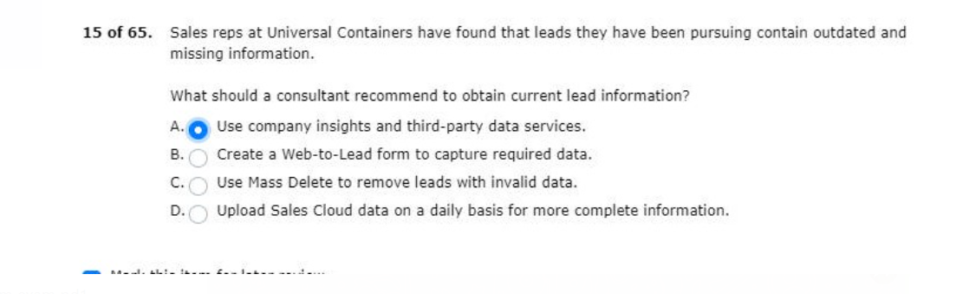
3.retain visibility of the reports in each folder.
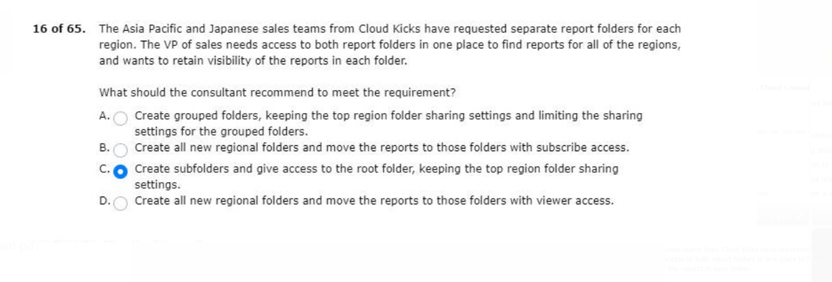
4.and the requirements still need to be defined.
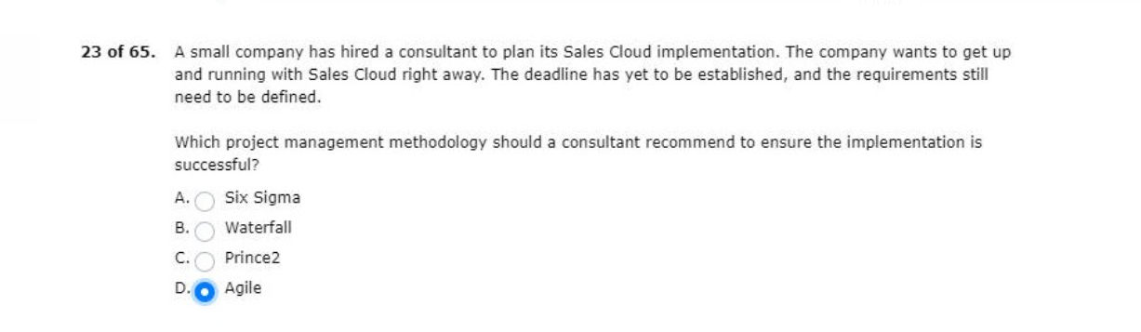
5.list on the account record in real time.
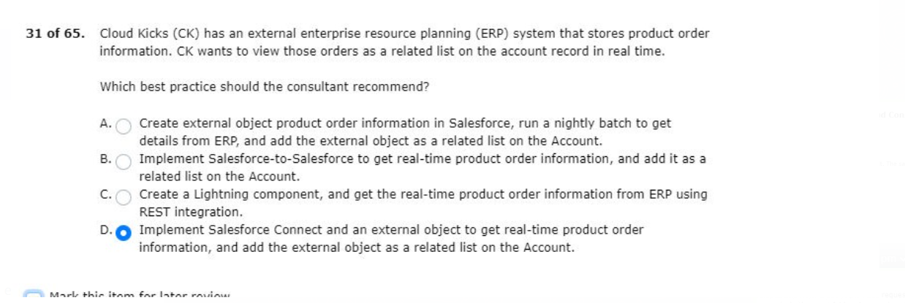

6.activities result in a successful sale.
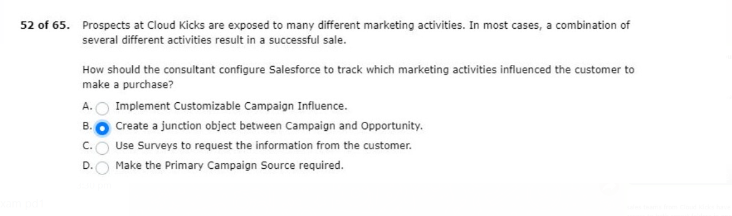
7.error messages all read unable to lock row.
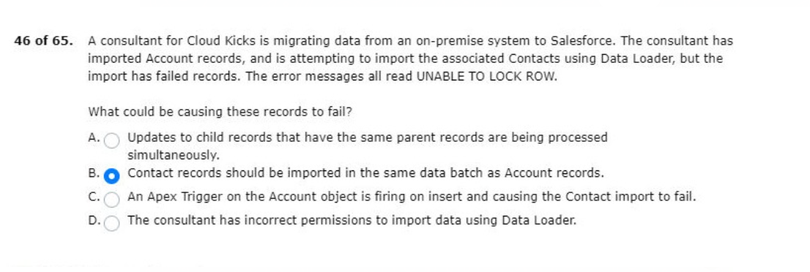
8.end users get up to speed on the product.
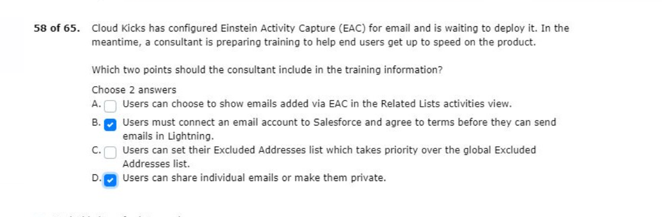
9.has suggested einstein opportunity insights.
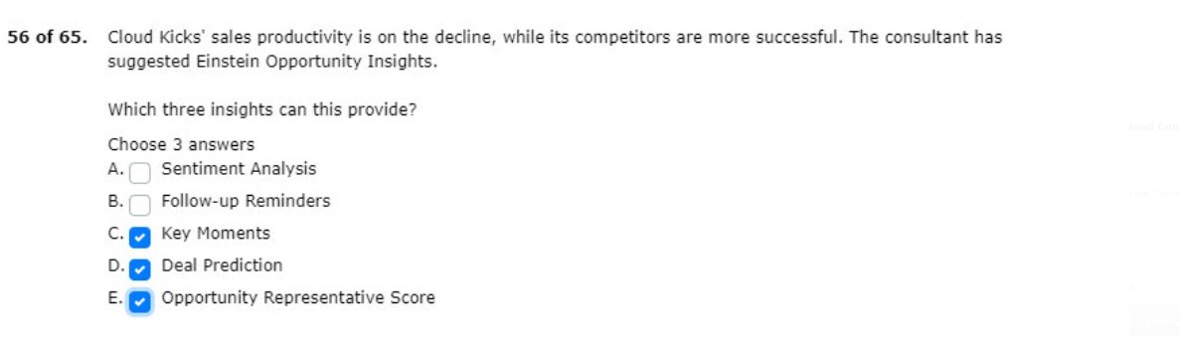

10.presenting this information to management.
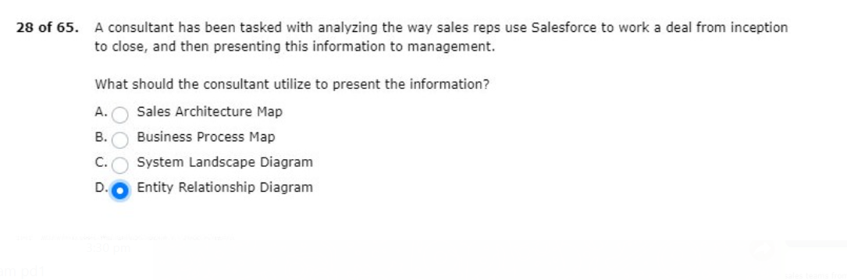
11.which provides flexibility for sales reps.
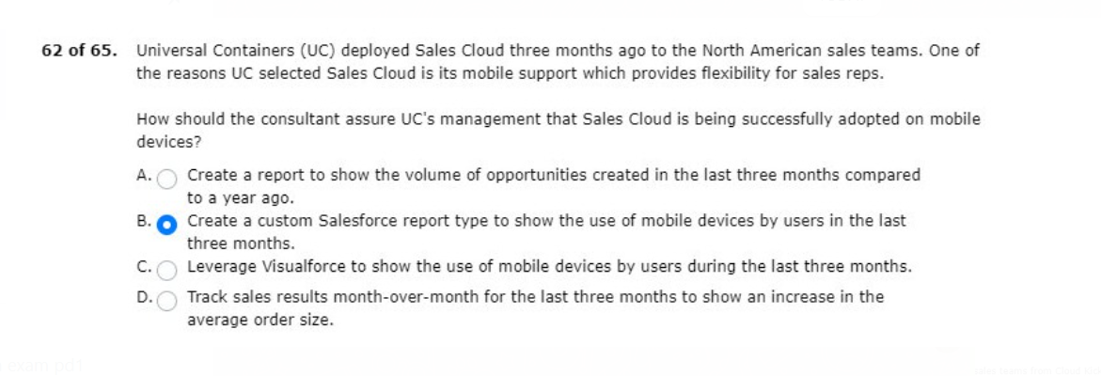
Based on the location of the related account.
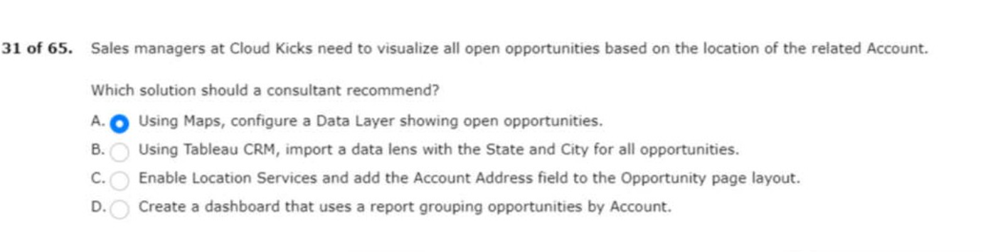

1.track the sales reps performance against these goals.
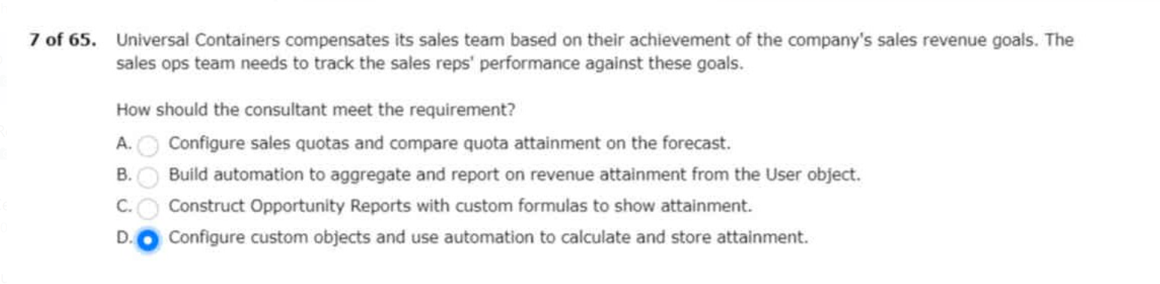

2.sales reps determine the right time to contact prospects.
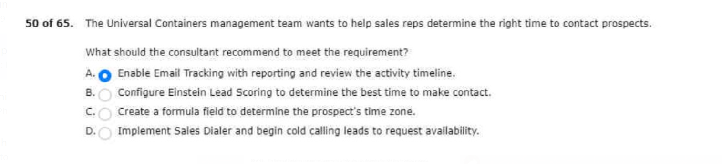
with the same sales rep after territory assignment rules are run.

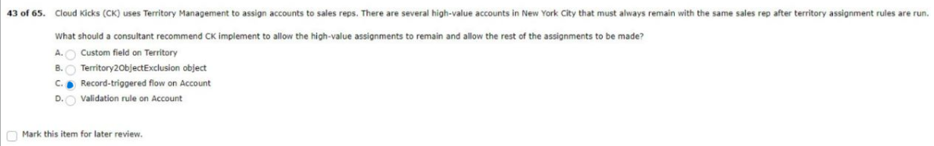

to start tracking the reasons why opportunties are being lost.
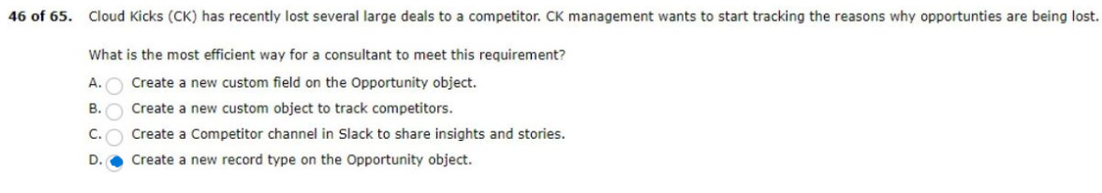

without setting up an Experience Cloud site.
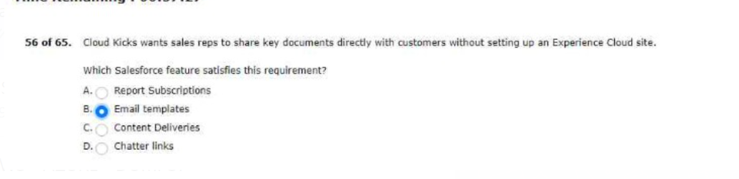

Salesforce lead and contact record data?

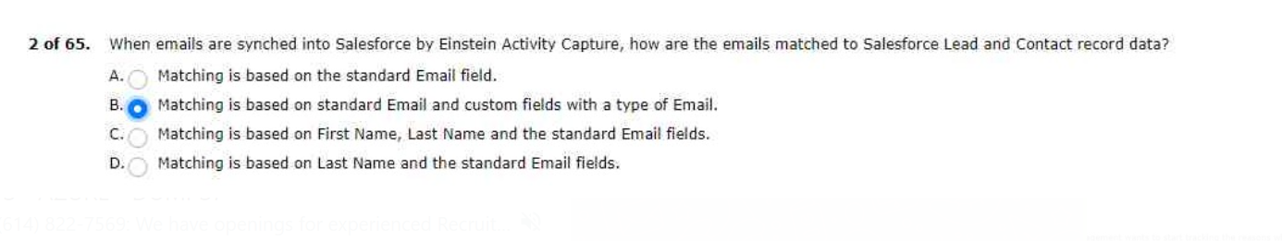
Rep after territory assignment rules are run.
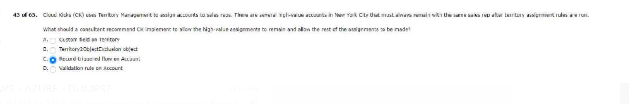
The reasons why opportunities are being lost.
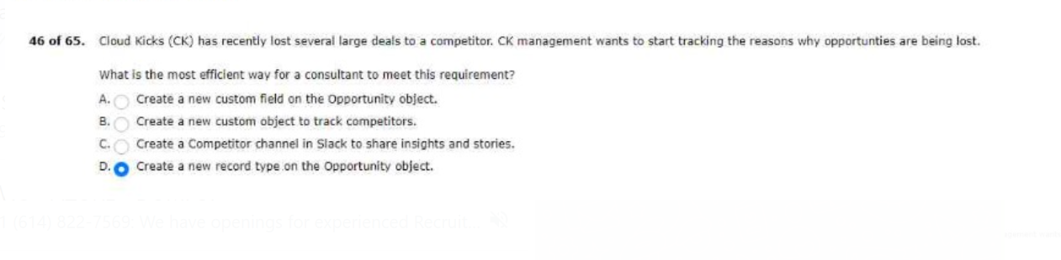
Income range between $50,000 and $70,000.
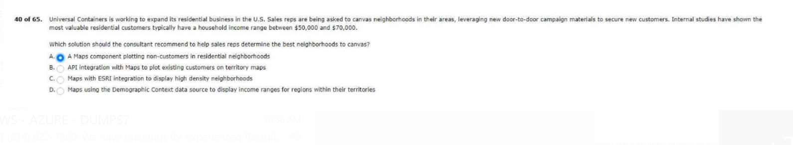
To add this product to any price book.

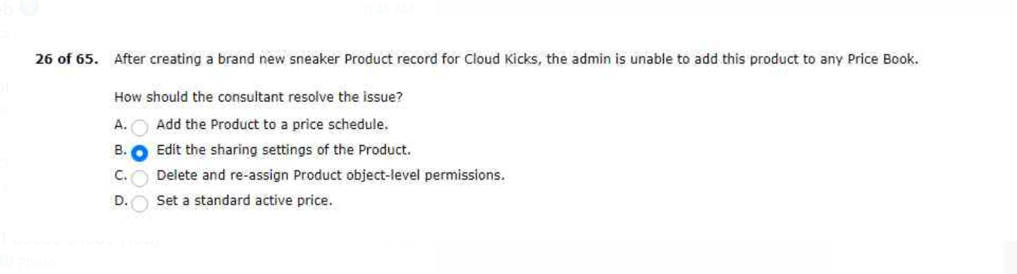

To track and report on these subscription deals.
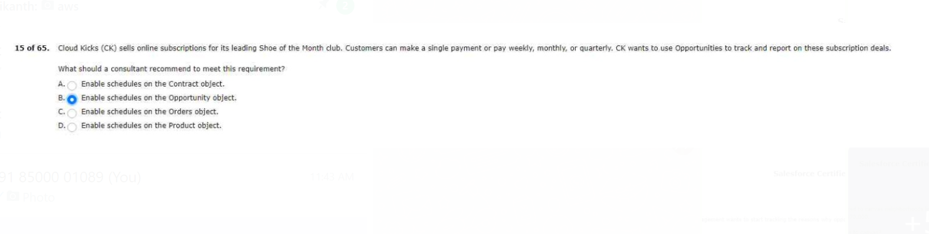
Have expresses dissatisfaction about moving to a new platform.
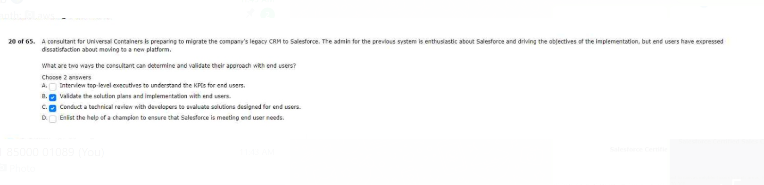
Some of the regional manager roles include multiple users.
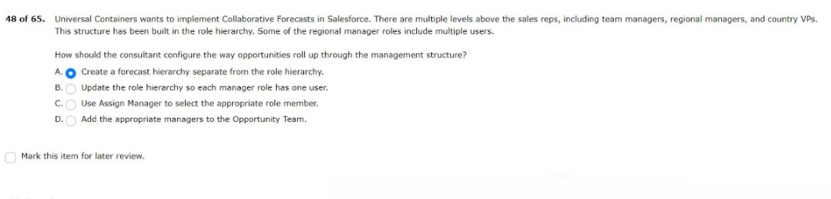

The consultant recommends using a developer pro sandbox as an initial step.

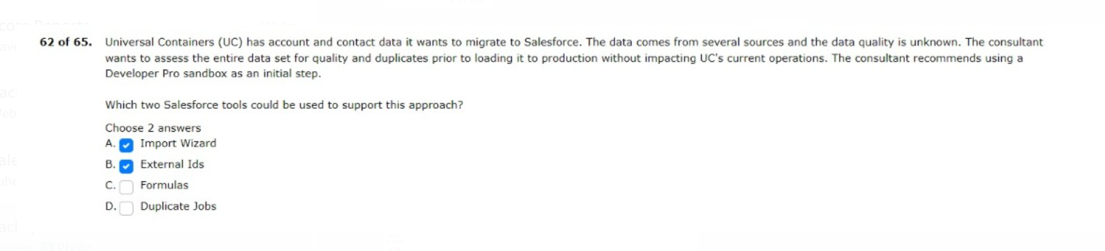

Three months ago and wants to gain insight into usage and data quality.
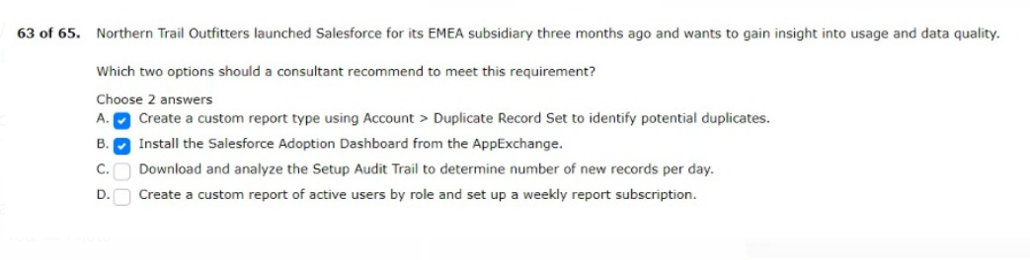
Person accounts have been enabled in its salesforce org.
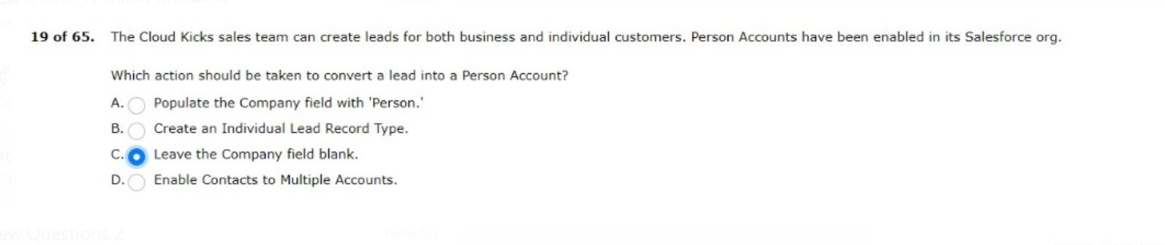
Managers like to measure the win ratio for all of the sales associates.
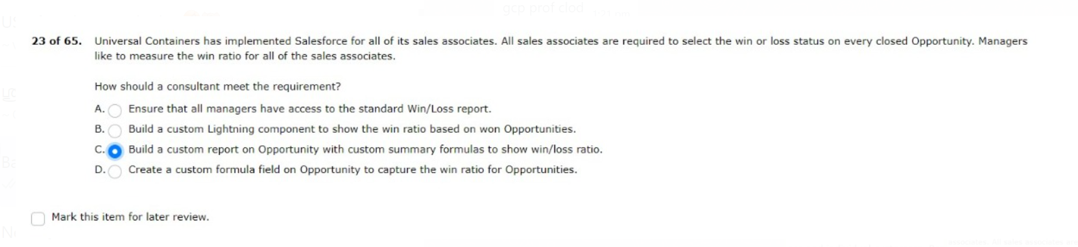
Must approve discounts greater than 10%.
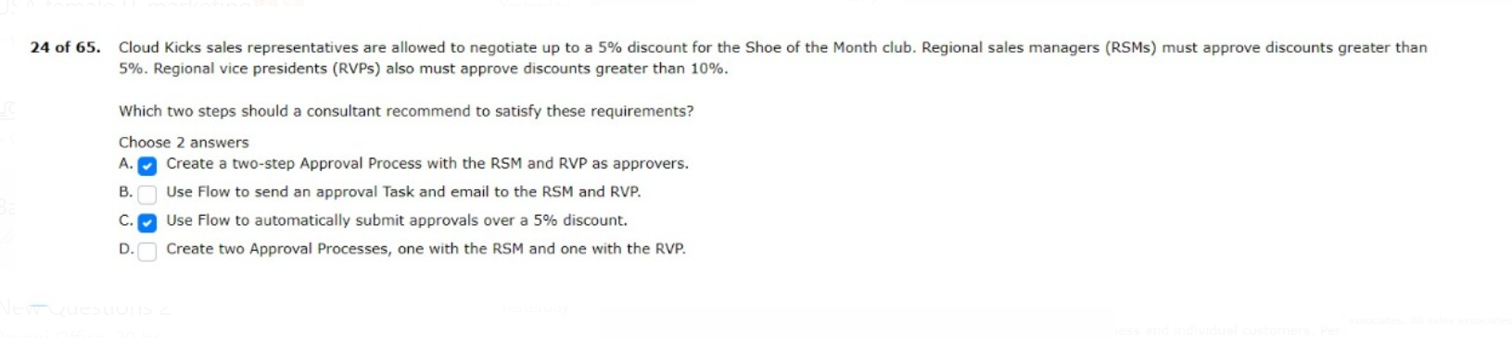
Orders to help sales reps process repetitive orders.
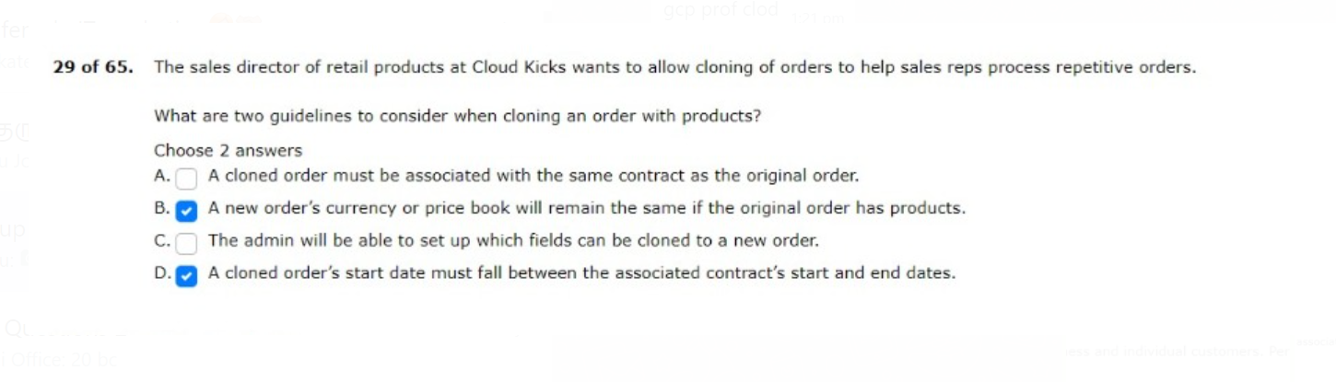

Some opportunities appear in the incorrect forecast category.
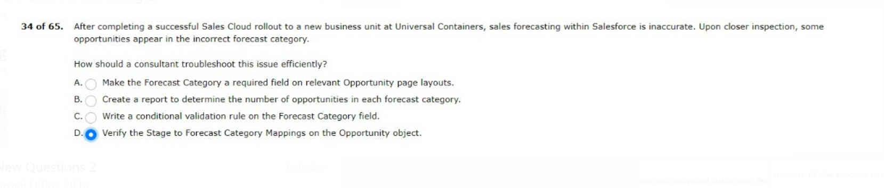
Who are responsible for those specific accounts?
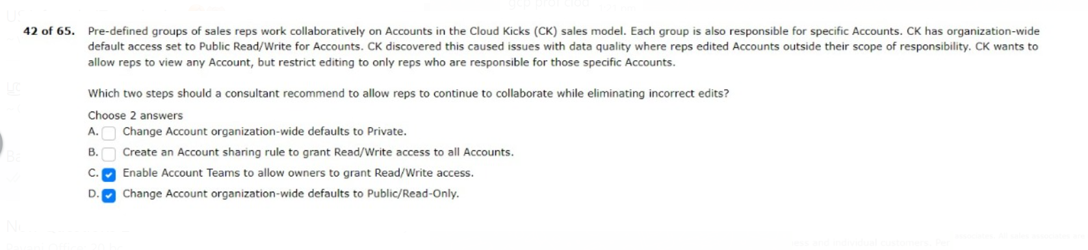
Bases and compare the month-over-month results.
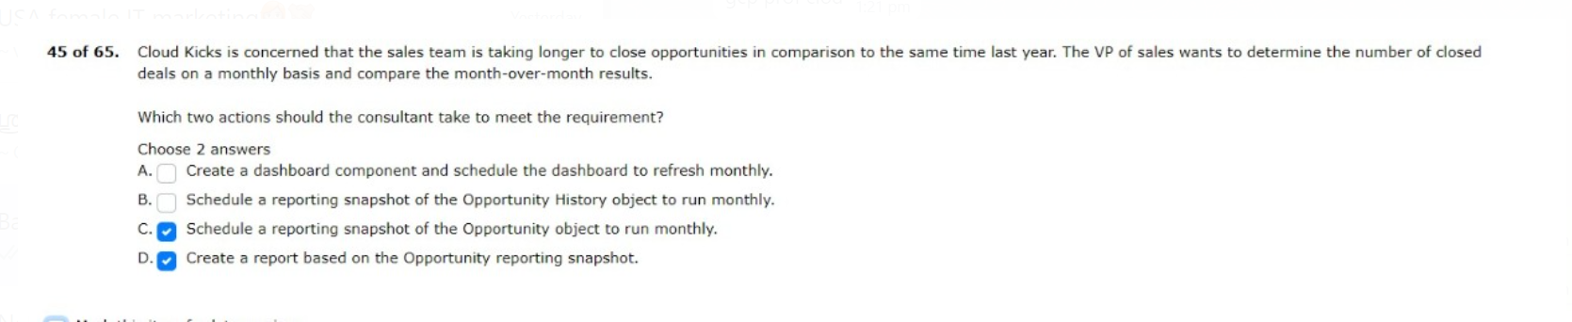
Better coordinate with the logistics departments to fulfill ordered.
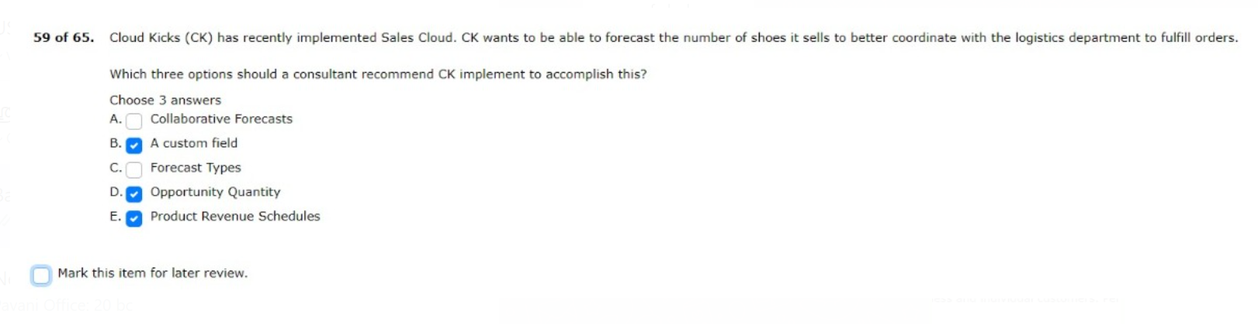
The internet is unavailable on their android and ios mobile devices.
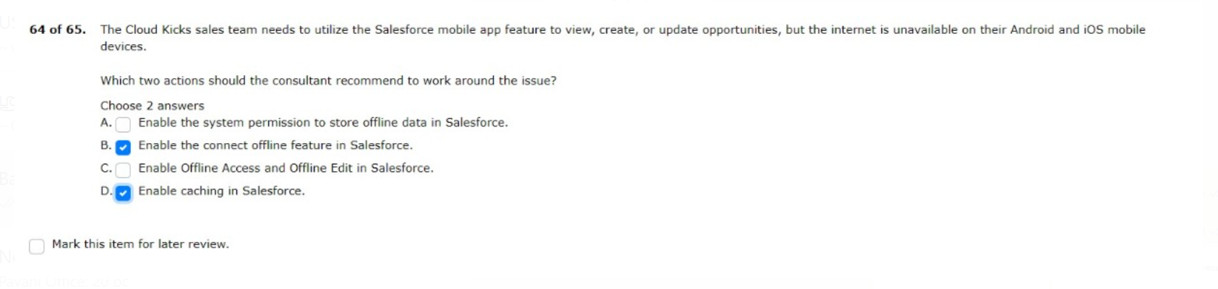

The sales director is requesting a detailed roll-up forecast for territories.
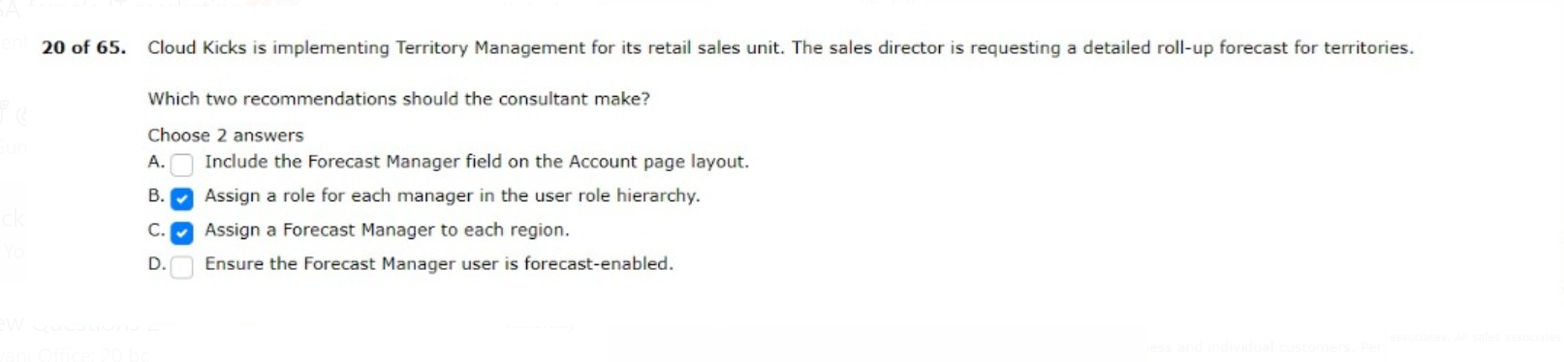
Unable to see a forecast for the current quarter.
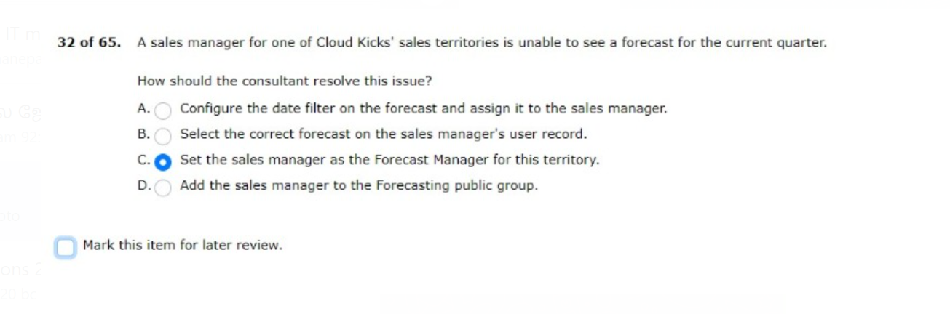
Revenue amount that combines all products together.
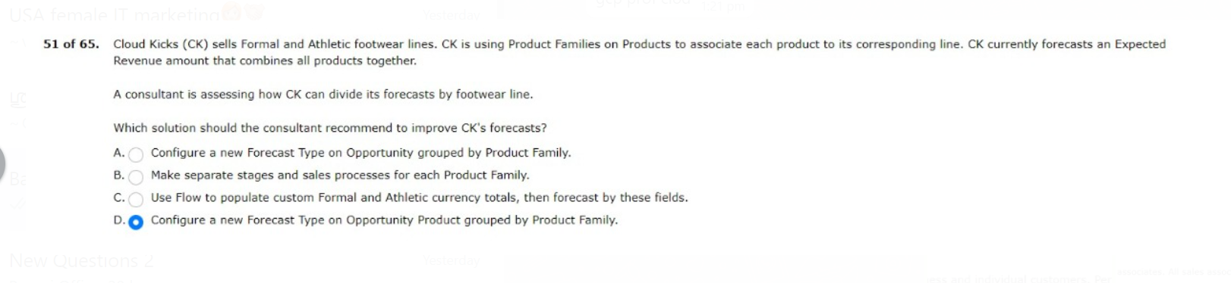
Much time coordinating meetings with prospective clients.
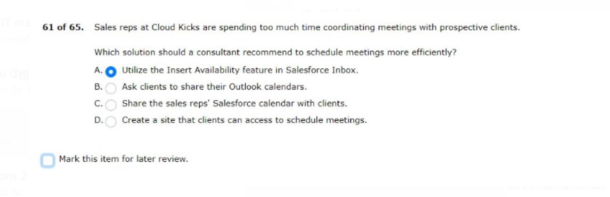

The adoption of salesforce files and multi-factor authentication.
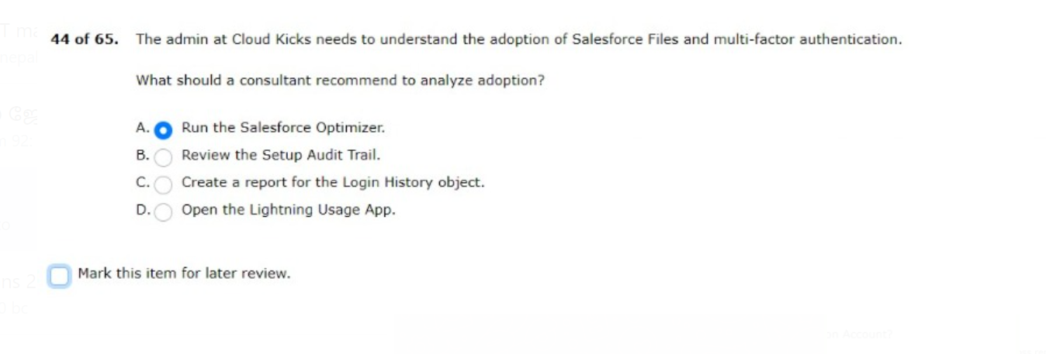

Which represents contacts that were generated from the website

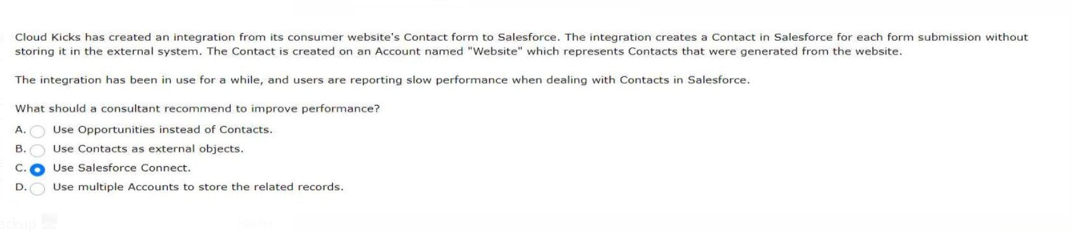
Lead object is excluded from einstein lead scoring
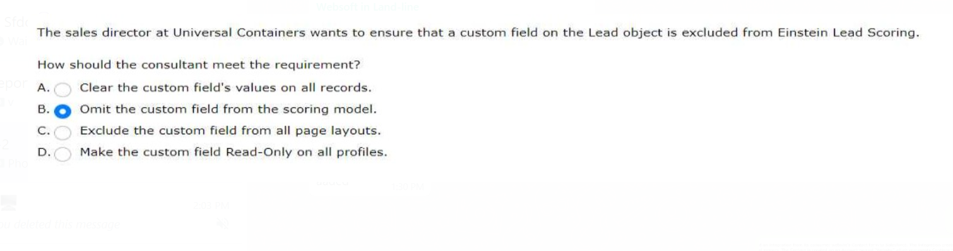
Hosted website to be reflected in salesforce
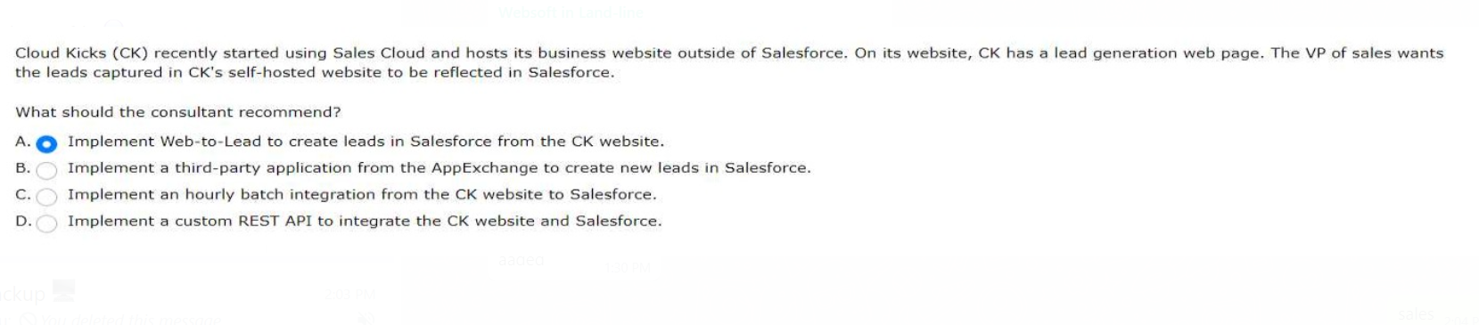

User will need to report on the forecast
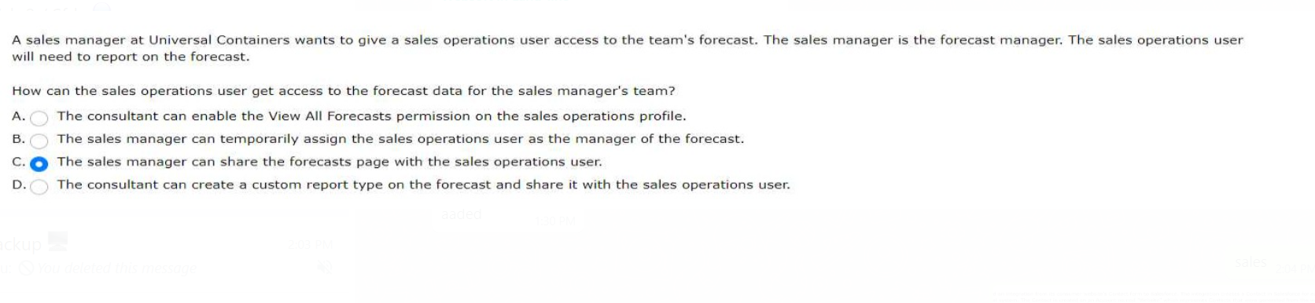
But their requests are being blocked
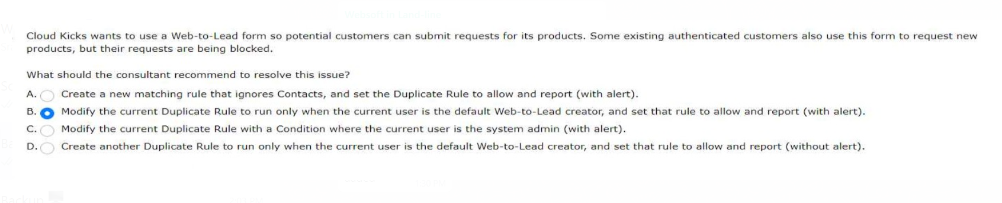
They want to justify the cost for future implementation phases
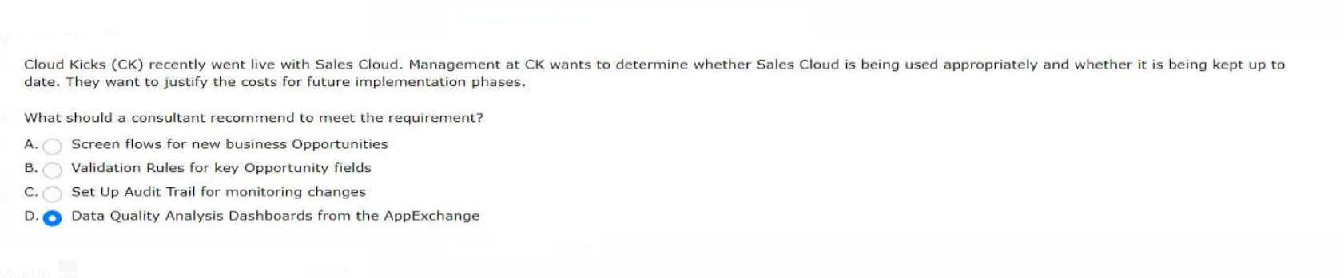
A sales rep at Cloud Kicks must have access to all child Accounts of the Accounts they own. The organization-wide default setting for Account is Private.
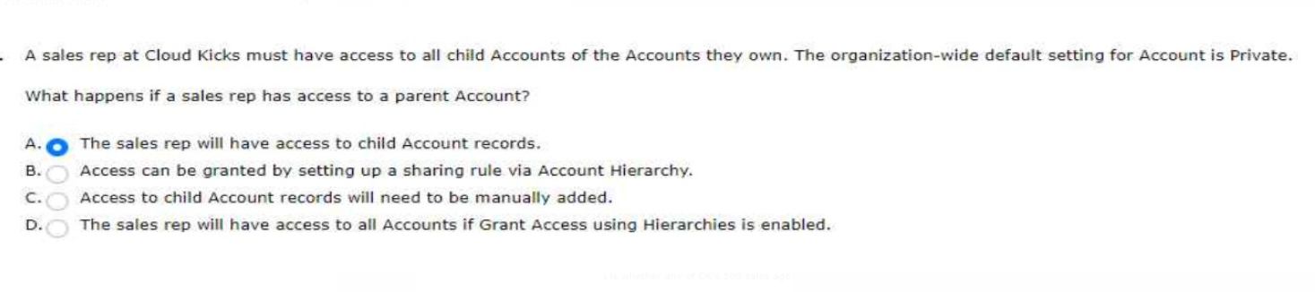
The Cloud Kicks marketing team purchased a marketing automation tool and is implementing a lead qualification process. The sales director provided key attributes and
activity history of the ideal lead.
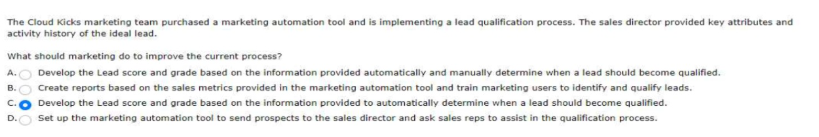

Cloud Kicks (CK) recently completed the first phase Of its Sales Cloud implementation. The consultants are determining which features and functionality should be ncluded in the next
phase. One factor they are considering is whether any of CK'S 500 sales agents are using a mobile device or a browser to access Salesforce.
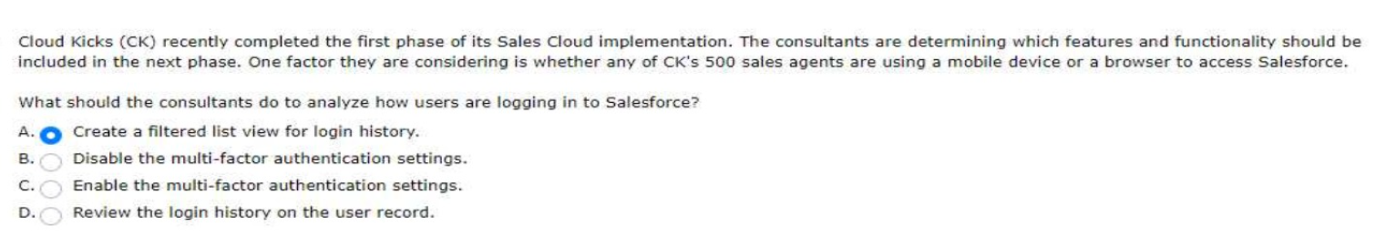
Opportunities in the Negotiation/Review stage should appear in the Commit category.
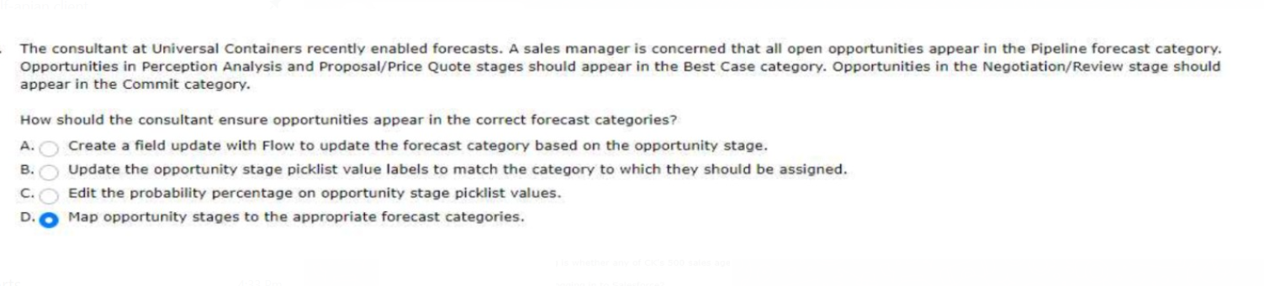
Cloud Kicks is implementing Sales Cloud and has asked a consultant to create an architecture diagram of the system.
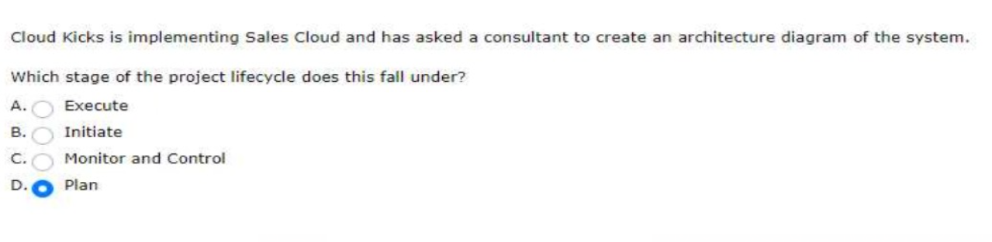
Cloud Kicks has a complicated sales process. Sales reps often have difficulty deciding when to move opportunities through various stages.
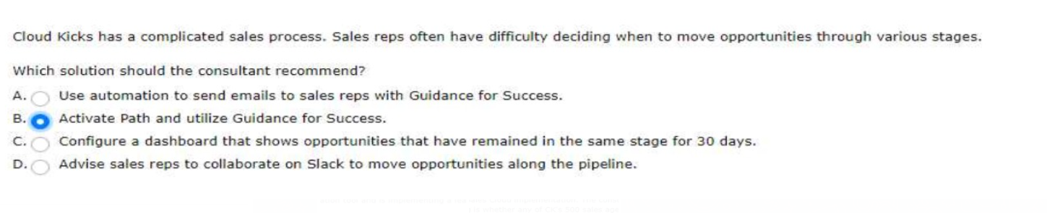
for every four prospect meetings held, one sale was generated.
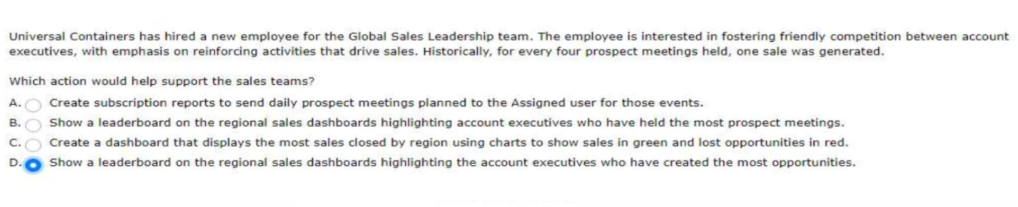

but they are receiving an error because the Product is associated to an Opportunity.
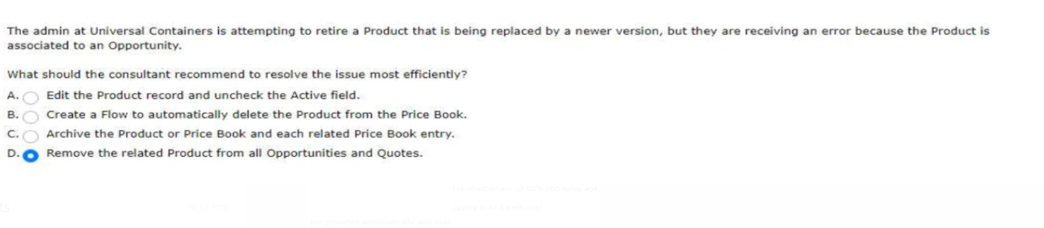
Enterprise Territory Management and role hierarchies are used.
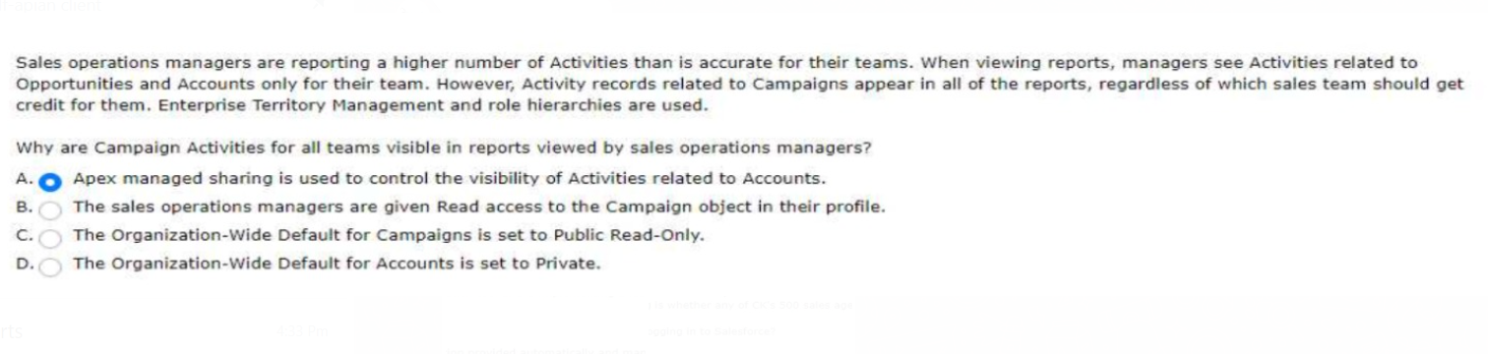
Cloud Kicks has 300,000 account records and 16 million invoices in a custom object with a master-detail relationship to the Account. Each account record takes a long time to display.

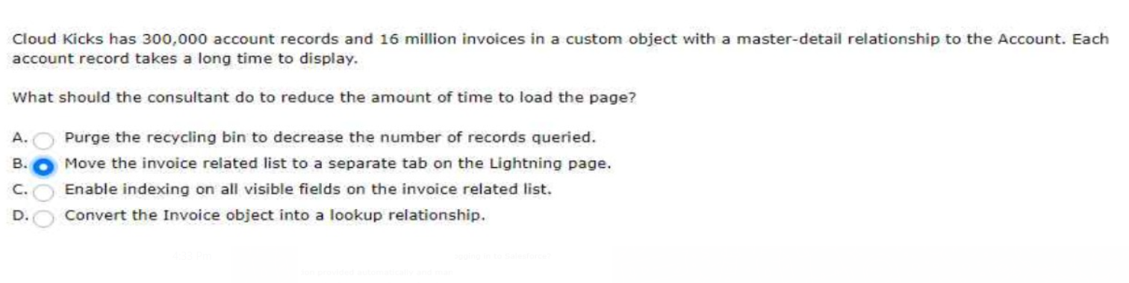
In these instances, accounts will need to be reassigned to new territories.
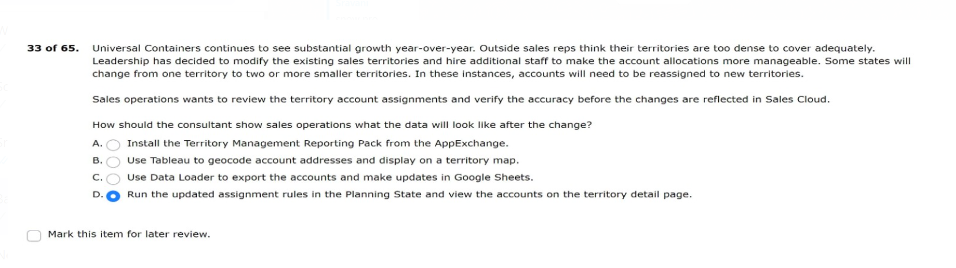

A consultant is beginning a new project with Cloud Kicks to implement Collaborative Forecasting.
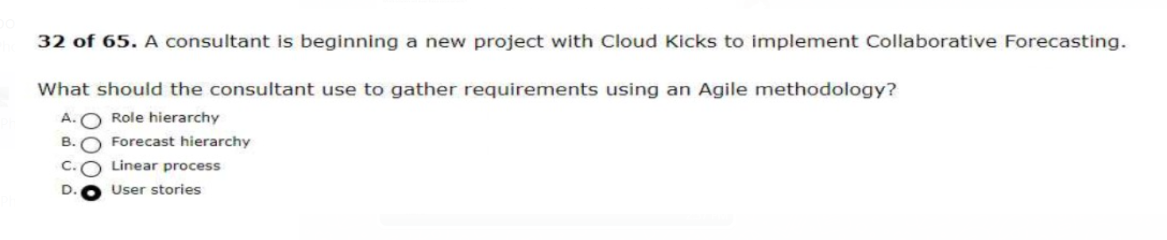
The team wants to determine the return on investment (ROI) for each industry conference.
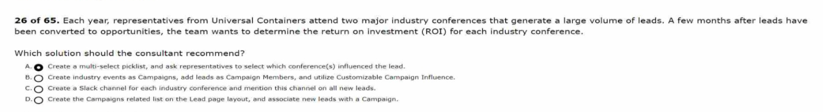
control the frequency of their email alerts.
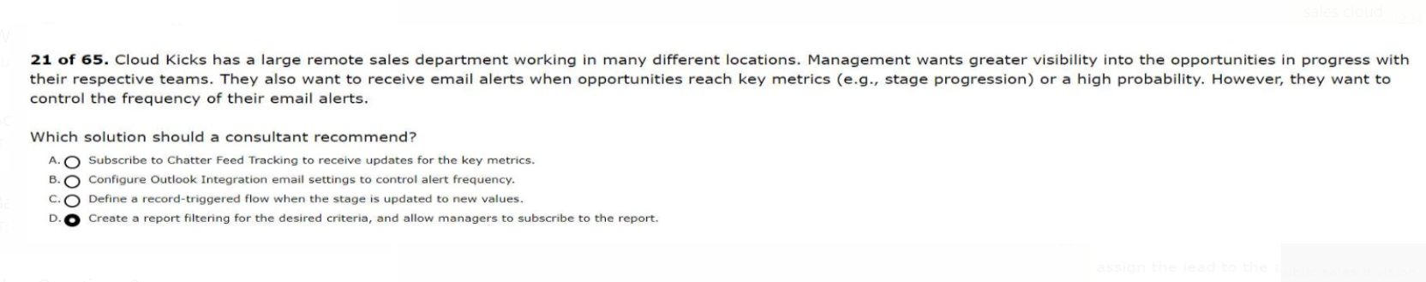
The new record should have the assignee's default record type.
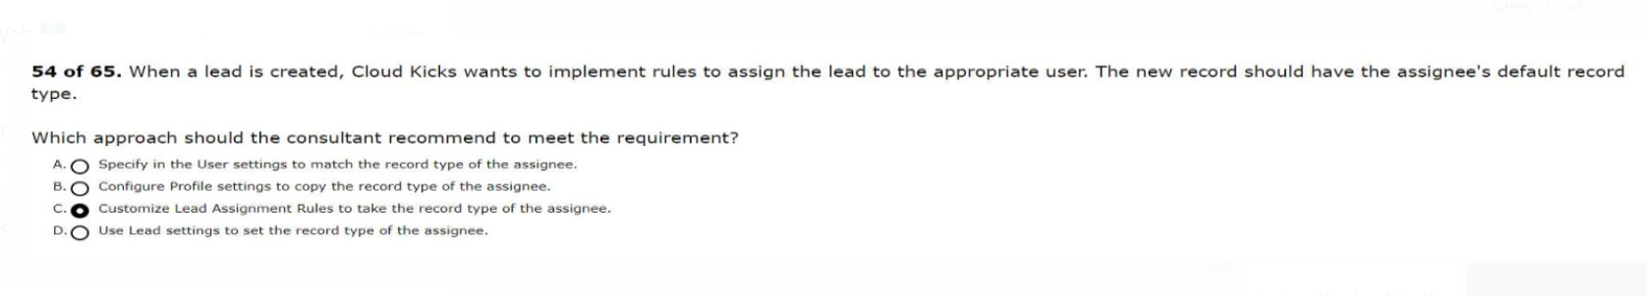

franchise sales division should only be able to set up Business Accounts.
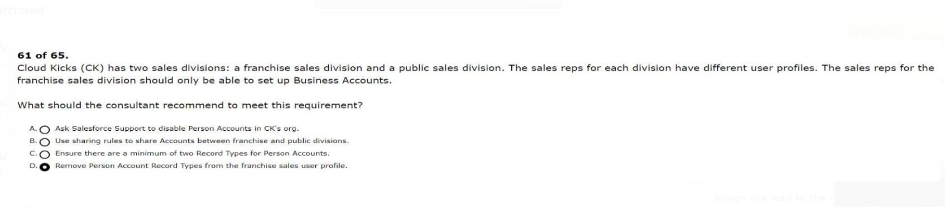
the support agent on their Account team is unable to edit the Account.
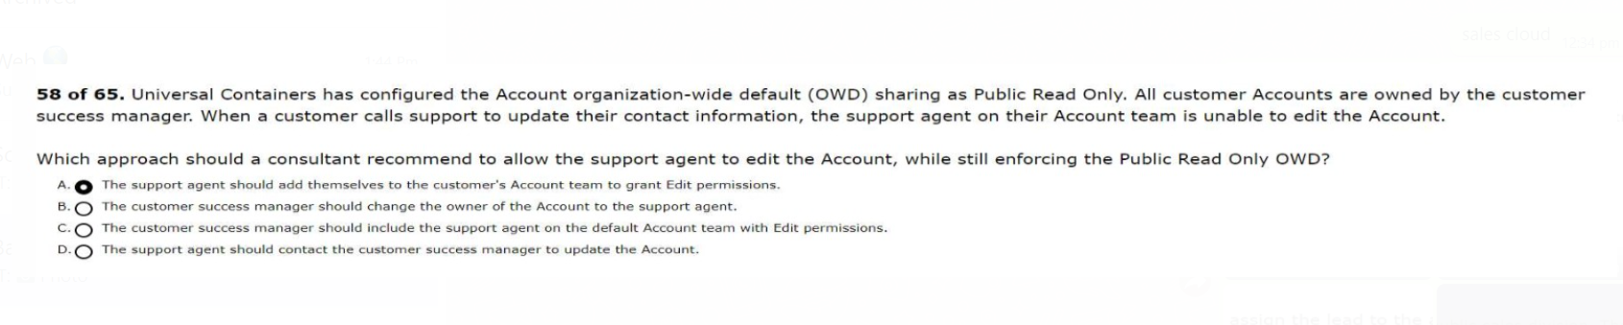
users are unable to see each other's accounts.
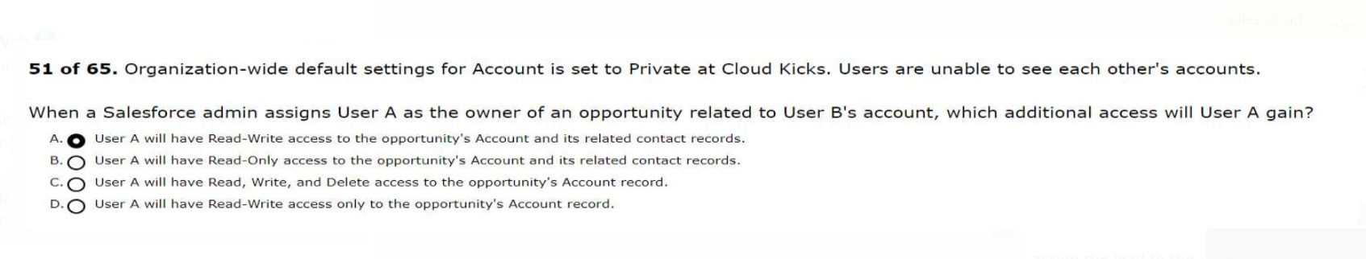
are missing from UC's Salesforce org because sales reps are unaware of them.
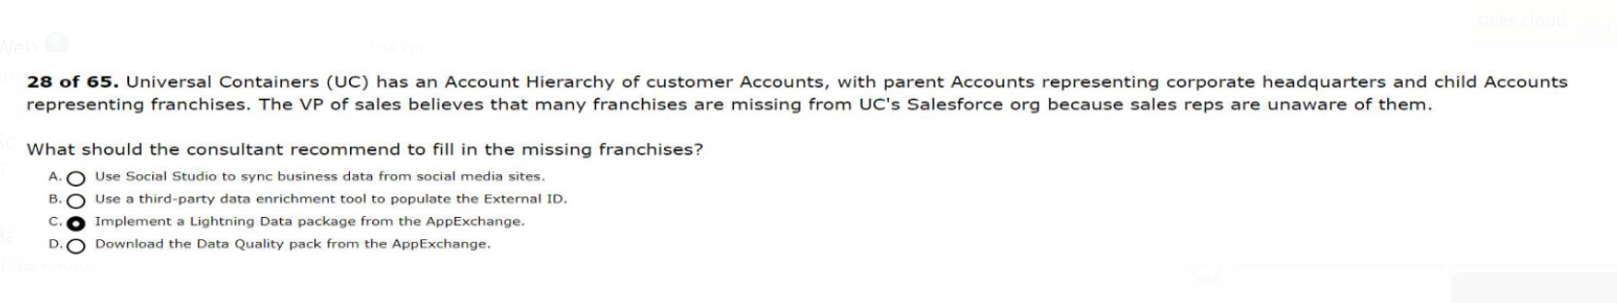
sentiments based on a Google Analytics Survey that was previously sent out.
